Multiple Columns Relationship

Original Data Source:

Customer_Master Table 🡪

|  |  |  |  |
| --- | --- | --- | --- |
| **CustID** | **ProdID** | **Date Of Enrollment** | **Product_Class** |
| C1 | P1 | 12-Dec-18 | A+ |
| C1 | P2 | 13-Jan-19 | B |
| C1 | P3 | 25-Mar-19 | A |
| C2 | P1 | 28-Apr-19 | B |
| C2 | P2 | 15-Nov-19 | A+ |

Customer_Billing Table 🡪

|  |  |  |  |
| --- | --- | --- | --- |
| **CustID** | **ProdID** | **Bill_Month** | **Amount** |
| C1 | P1 | Dec-18 | 2000 |
| C1 | P1 | Jan-19 | 2300 |
| C1 | P1 | Feb-19 | 300 |
| C1 | P1 | Mar-19 | 5000 |
| C1 | P1 | Apr-19 | 2400 |
| C1 | P2 | May-19 | 2900 |
| C1 | P2 | Jun-19 | 3000 |
| C1 | P3 | Jul-19 | 3300 |
| C1 | P3 | Aug-19 | 2700 |
| C2 | P1 | Sep-19 | 2100 |
| C2 | P1 | Oct-19 | 2200 |
| C2 | P2 | Nov-19 | 5000 |
| C2 | P2 | Dec-19 | 3100 |

Note 🡪 Here **CustID and ProdID** both need to be used for relationship.

When we link CustID of both the tables and then link ProdIDs of those tables then that relationship by default becomes inactive as shown next 🡪

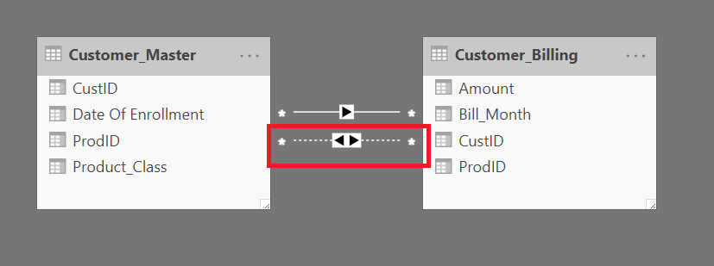

The relationships window for ProdID link will have the following look:

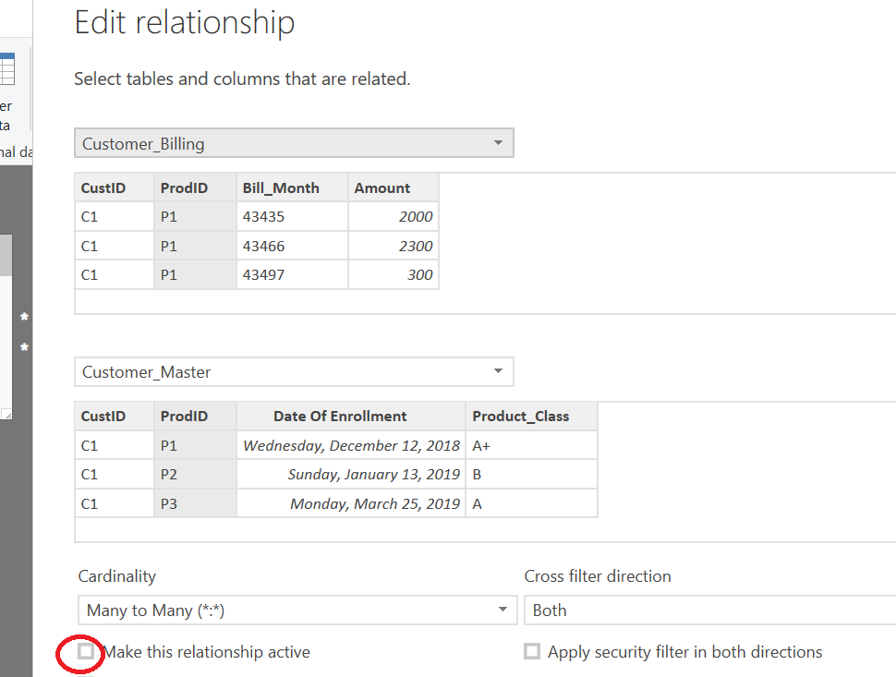

If we try to make that relationship active then Power BI throws the error as shown next 🡪

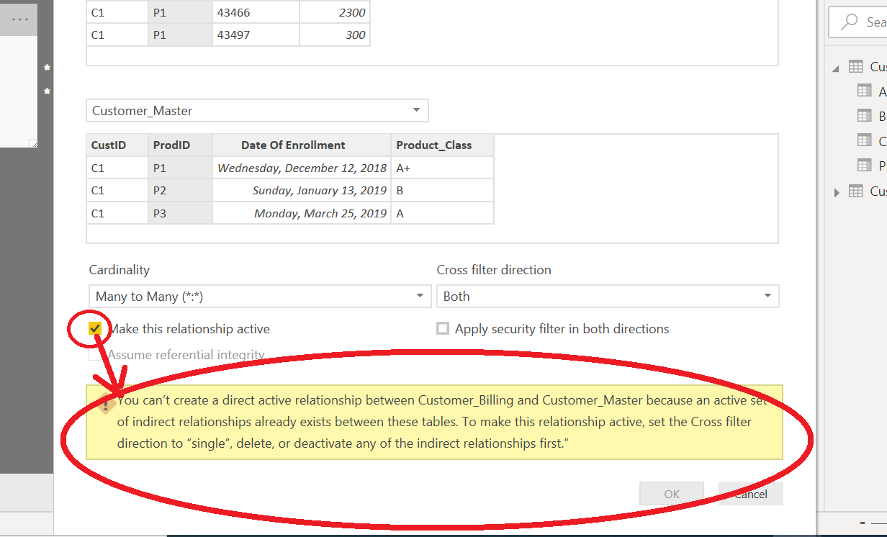

**So, at a time we cannot have 2 relationships active.**

Solution:

1. Create a **new column** which will have concatenation of CustID and ProdID in **Customer_Master** table.

**CustId_ProdId = Customer_Master[CustID]&Customer_Master[ProdID]**

1. Create similar concatenated column in **Customer_Billing** table.

**CustId_ProdId = Customer_Billing[CustID]&Customer_Billing[ProdID]**

1. Delete all the existing active and inactive relationships
2. Create the relationship between the newly created column of both the tables as shown next 🡪

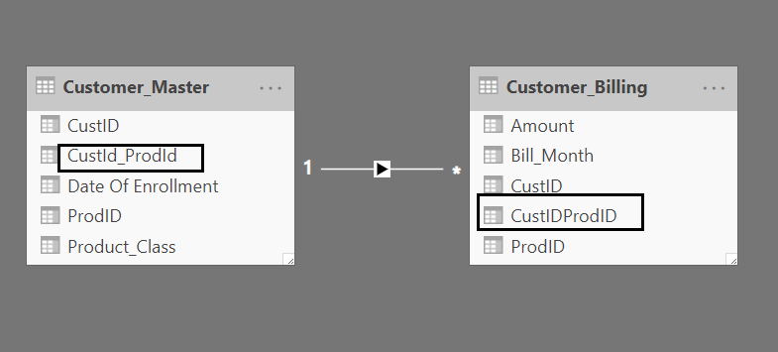

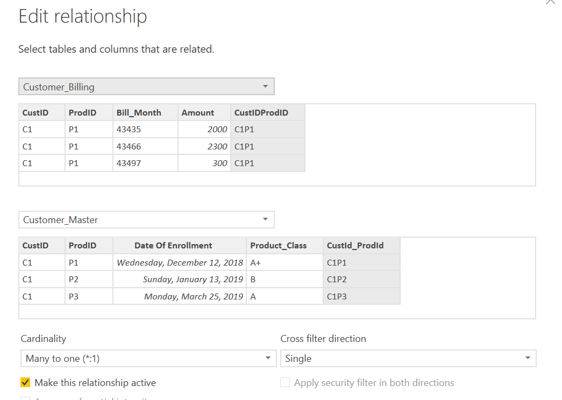

1. In Reports section place a Matrix
   1. Put Product_Class into **Rows**
   2. Put CustID into **Columns**
   3. Put Amount into **Values** as shown next 🡪

